


4BUIS006C.3 Requirements Modelling Group Course Work
Group B6

Group Members
Name | IIT ID | UOW ID
Vinudi Ranadeera | 20232111 | W2120868
Thakshila Kavindi | 20232963 | W2120881
Thisandi Hettiarachchi | 20231599 | W2120880
Muhammed Akmal | 20230632 | W2120896

Acknowledgments
We would like to express our sincere gratitude to our lecturer, Ms. Aniqah Zeezan, for her valuable guidance and support throughout this project. Her insights and expertise have been crucial in helping us develop a comprehensive understanding of the subject.
We also extend our appreciation to our tutor, Ms. Janadhi Weranja, for her continuous assistance and constructive feedback, which greatly contributed to the improvement of our work.
A special thank you to our colleagues for their collaboration, dedication, and teamwork. The collective effort and shared knowledge made this project both enriching and enjoyable.
Lastly, we are deeply grateful to our families for their unwavering support and encouragement, which kept us motivated throughout this journey.
Sincerely,
B6.

Table of Contents
Acknowledgments i
Table of figures iii
List of Tables iii
1. Introduction 1
2. Group Organization and Work plan 3
3. Stakeholder Analysis 6
3.1 Stakeholder Onion Diagram 6
3.2 Stakeholder Descriptions 7
4. Use Case Diagram 9
5. List of Requirements 10
5.1. Business Requirements 10
5.2. User Requirements & System Requirements 10
6. UML Activity Diagrams 13
6.1. Activity Diagram for “View sustainability challenges” 13
6.2. Activity Diagram for “Upload sustainability challenges” 14
6.3. Activity Diagram for “View sustainability events” 15
6.4. Activity Diagram for “View sustainability resources” 16
7. References 17
APPENDIX 18
Appendix A – Draft / Earlier versions of Stakeholder Analysis 18
Appendix B – Draft / Earlier versions of Use case diagrams 19
Appendix C – Draft / Earlier versions of Requirements 22
Appendix D – Draft / Earlier versions of Activity Diagrams (group by student) & feedback 25
Vinudi Ranadeera-20232111- W2120868 Earlier version of Activity Diagram for “View sustainability challenges” 25
Thakshila Kavindi-20232963- W2120881 Earlier version of Activity Diagram for “Upload sustainability challenges” 27
Thisandi Hettiarachchi-20231599- W2120880 Earlier version of Activity Diagram for “View sustainability events” 29
Muhammed Akmal-20230632- W2120896 Earlier version of Activity Diagram for “View sustainability resources” 31
Appendix E – Interview script 33

Table of figures

Figure 1:Stakeholder onion diagram 6
Figure 2: Use case diagram 9
Figure 3:Activity Diagram for “View sustainability challenges” - Vinudi Ranadeera - 20232111- W2120868 13
Figure 4: Activity Diagram for “Upload sustainability challenges” - Thakshila Kavindi - 20232963- W2120881 14
Figure 5:Activity Diagram for “View sustainability events” - Thisandi Hettiarachchi - 20231599 - W2120880 15
Figure 6:. Activity Diagram for “View sustainability resources” - Muhammed Akmal - 20230632 - W2120896 16
Figure 7:Draft / Earlier version of Stakeholder Analysis 18
Figure 8:Draft / Earlier versions of Use case diagram 1 19
Figure 9:Draft / Earlier versions of Use case diagram 2 21
Figure 10:Vinudi Ranadeera-20232111- W2120868 Earlier version of Activity Diagram for “View sustainability challenges” 25
Figure 11:Thakshila Kavindi-20232963- W2120881 Earlier version of Activity Diagram for “Upload sustainability challenges” 27
Figure 12: Thisandi Hettiarachchi-20231599- W2120880 Earlier version of Activity Diagram for “View sustainability events” 29
Figure 13:Muhammed Akmal-20230632- W2120896 Earlier version of Activity Diagram for “View sustainability resources” 31

List of Tables
Table 1: Work plan 5
Table 2:Stakeholder descriptions 8
Table 3:List of requirements 12
Table 4:Draft / Earlier version of Requirements 24

Introduction
Contributors: Vinudi, Thisandi, Akmal
The Green Westminster – Westminster Sustainability Engagement Platform is a proposed initiative aimed at enhancing the engagement of students and staff with the University of Westminster’s sustainability efforts. However, despite these efforts, there are challenges in creating widespread awareness and maintaining motivation for long-term sustainable behavior among the university community. The intended platform will act as a central location for events, activities, and information pertaining to sustainability, eventually encouraging an environmentally conscious culture among university students.
High Level Aims and Objectives
- Increase Awareness: Improve communication and promotion of sustainability initiatives, addressing the limitations of the current system, which lacks engagement opportunities (UNESCO, 2021).
- Boost Engagement: Enable students and staff to actively participate in sustainability challenges and events through registration, proof of completion, and showcasing achievements (University of Westminster, 2023).
- Encourage Long-Term Behavior Change: Use gamification, leaderboards, rewards, and impact metrics to maintain motivation and turn sustainable practices into lasting habits (Hamari, Koivisto & Sarsa, 2014).
Motivation and Purpose
This platform's main goal is to close the gap between the university's sustainability objectives and the community members' actual participation. There is currently little involvement in sustainability initiatives, and many academic staff and students are unsure of how to get involved. By providing clear pathways to participation and rewarding positive behavior with incentives and recognition, the new platform seeks to create a more user appealing and captivating experience.
Scope
The platform will be a responsive website exclusively accessible to current university students and academic staff through their institutional login credentials.
Key features will include:
- Event Calendar & Registration: Discover and register for green events.
- Gamification & Leaderboards: Friendly competitions and points-based rewards.
- Impact Trackers Visual tools to show users their carbon footprint savings.
- Educational Resources: Guides, articles, and videos on sustainability practices.
- Reward System: Earn points for green actions, redeemable for discounts on campus services or merchandise.
- Social Sharing & Community Engagement: Engage in discussions, share ideas, and celebrate achievements.

Purpose of the Report
This report documents the requirement-gathering process for the Green Westminster platform, detailing stakeholder interviews and analysis, and outlining business, user, and system requirements. It also includes diagrams and models to illustrate platform functionality and stakeholder interactions.
- Group Organization and Work Plan: How the team organized tasks and managed the project timeline.
- Stakeholder Analysis: Identifying key stakeholders and their roles in the project.
- Use Case Diagram: Visual representation of the platform's key use cases.
- List of Requirements: Detailed business, user, and system requirements.
- UML Activity Diagrams: Step-by-step workflows for selected use cases.
- References and Appendices: Supporting materials, including draft versions of analyses and diagrams.
JARAGONS
UR – User requirement
SR – System requirement
UML - Unified Modeling Language
IT- Information Technology
UNESCO - United Nations Educational, Scientific and Cultural Organization.
SDG - Sustainability development goals
FR - Functional requirement
NFR - Non functional requirement

Group Organization and Work plan
Contributors: Vinudi, Thisandi
Meetings | Meeting Attendance | Details discussed in the meeting | Decisions/Contributors
4TH February  (Online meeting) | - Vinudi  - Thakshila  - Thisandi  - Akmal | - Went through the coursework specification.  - Appointed Vinudi as the group leader.  - Delegated the work. | - Decision:  Appointed Vinudi as the group leader and delegated the work among team members to ensure effective management and balanced workload distribution for the coursework.  - Contributors:  Vinudi: Accepted the role of group leader and will oversee task progress.  All Team Members: Participated in discussing the coursework specification and agreed on task delegation.
5th February  (IIT premises) | - Vinudi  - Thakshila  - Thisandi  - Akmal | - Reviewed all ideas presented by group members and addressed any doubts or concerns.  - Prepared a set of questions for the upcoming interview to gather relevant information. | - Decision:  Made the interview questions based on the ideas discussed and the doubts clarified during the meeting.  - Contributors:  All Group Members: Shared ideas and raised questions for clarification.  Vinudi, Akmal - Facilitated the discussion and helped in formulating the interview questions  Thakshila, Thisandi – Written down the questions we made.
11th February  (IIT premises) | - Vinudi  - Thakshila  - Thisandi  - Akmal | - Discussed and assigned roles for the interview:  - Interview Lead  - Questioner  - Note-taker  - Time keeper | - Decision:  Finalized the interview questions.  - Contributors:  All Group Members: Provided input on the interview process and volunteered for roles.
18th February  (IIT premises) | - Vinudi  - Thakshila  - Thisandi  - Akmal | - Using our interview minutes, we prepared the list of requirement table. | - Decision:  Prepared the list of requirements table using the interview minutes as a basis for identifying key information.  - Contributors:  All Group Members: Contributed by reviewing the interview minutes and identifying the relevant requirements.
21th February  (Online meeting) | - Vinudi  - Thakshila  - Thisandi  - Akmal | - Discussed the feedback we got for the list of requirement table. | - Decision:  Reviewed and discussed the feedback received for the list of requirements table to ensure all necessary adjustments and improvements were made.  - Contributors:  All Group Members: Provided feedback and suggestions for refining the requirements table.
25th February  (IIT premises) | - Vinudi  - Thakshila  - Thisandi  - Akmal | - Drawing the use case diagram | - Decision:  Identify the actors, define the use cases, determine the relationships, ensure clarity in scope  - Contributors:  All group members: Contributed to draw the use case, identifying the dependencies, finalized to get the feedback
27th February  (Online meeting) | - Vinudi  - Thakshila  - Thisandi  - Akmal | - Finalized the use case diagram, chose the use case for the activity diagrams | - Decision:  Drew the use case using draw.io  Chose the use cases for our activity diagrams  - Contributors:  All members discussed the feedback we got. Vinudi drew the diagram, Thakshila crosschecked.
4th March  (IIT Premises) | - Vinudi  - Thakshila  - Thisandi  - Akmal | - Feedbacks for activity diagrams | - Decision:  Gave feedbacks to each other  - Contributors:  All members gave feedbacks to each other.
10th March  (IIT Premises) | - Vinudi  - Thakshila  - Thisandi  - Akmal | - Discussed about the report making | - Decision:  Started to fill the gaps in the report, finalized our activity diagrams.  - Contributors:  All members gathered information, gaps, Vinudi formatted the report
12th March  (IIT Premises) | - Vinudi  - Thakshila  - Thisandi  - Akmal | - Finalized the report | - Decision:  Proof reading the report  - Contributors:  All group members crossed check their own diagrams, checked the report
Table 1: Work plan

Stakeholder Analysis
Contributors: Akmal, Vinudi, Thakshila

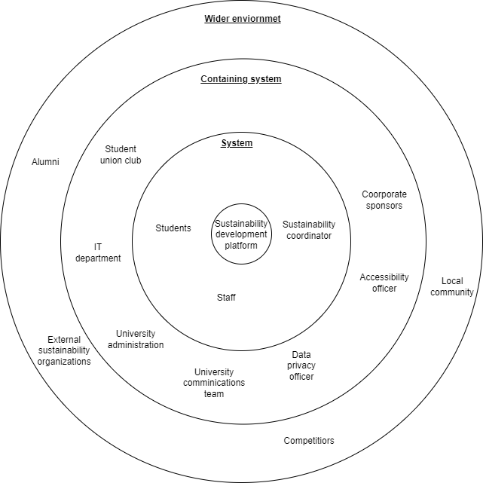
Stakeholder Onion Diagram
Figure 1:Stakeholder onion diagram

Stakeholder Descriptions
Role | Description
System
Students | Primary users, actively participate in sustainability initiatives, utilize resources, provide feedback.
Staff | Primary users, participate in initiatives, utilize resources, provide feedback.
Sustainability Team Coordinator (Admin) | Manages the platform, adds content, creates challenges, monitors engagement, updates carbon impact tracker.
Containing System
Student union club | Promote the platform, organize events, contribute content, provide feedback.
IT Department | Develops, maintains, and supports the platform's technical infrastructure.
University Administration | Provides funding, approves proposals, sets goals, monitors impact.
University Communications Team | Promotes the platform, raises awareness, manages communication.
Data Privacy Officer | Ensures data compliance, advises on data practices, safeguards privacy.
Accessibility Officer | Ensures platform accessibility for users with disabilities.
Corporate Sponsors | Provide rewards and incentives for participating in sustainability challenges.
Wider Environment
Alumni | Potential future users, may participate in alumni-focused initiatives.
External Sustainability Organizations | Collaborate on projects, provide expertise, resources, and funding.
Local Community | May be involved in local initiatives, benefit from projects, provide feedback.
Competitors | Understand system features to improve their offerings and gain competitive advantage.
Table 2:Stakeholder descriptions

Use Case Diagram
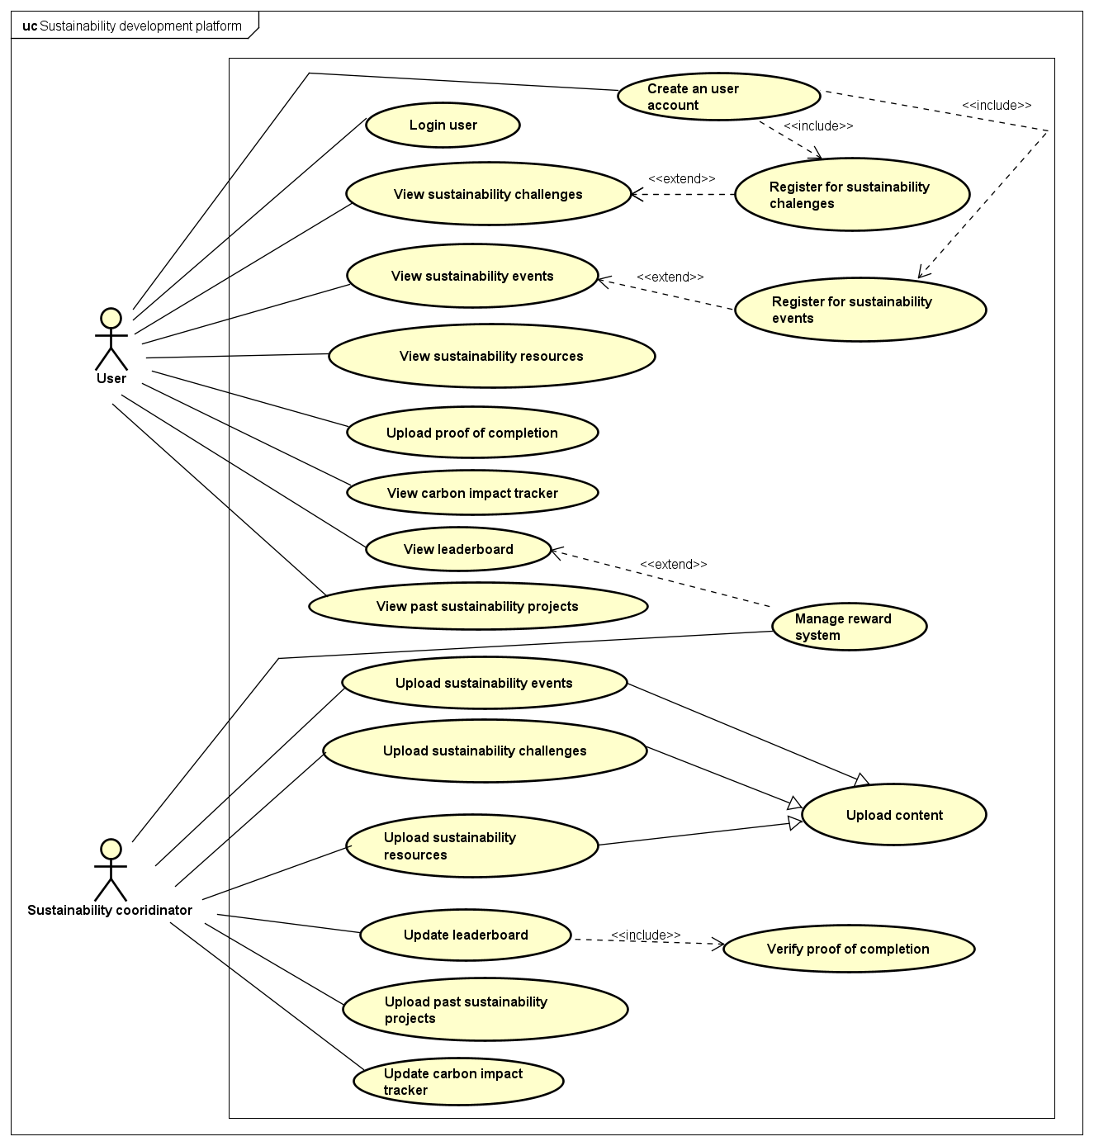
Contributors: Vinudi, Thakshila
Figure 2: Use case diagram

List of Requirements
Contributors: Vinudi, Thakshila, Thisandi, Akmal

5.1. Business Requirements
- The platform should serve as a central hub for students and staff to participate in sustainability initiatives, track environmental impact, and contribute to a greener university.
- The system should encourage users to actively participate in sustainability challenges and events by providing an easy-to-use interface and a streamlined registration process.
- A structured reward system should be in place to motivate users to complete sustainability challenges and events, promoting long-term engagement.
- The platform should provide a secure way for users to submit proof of challenge and event completion, with an admin verification process to maintain credibility.
- The platform should educate users by offering access to sustainability-related resources, past projects, and environmental impact data to raise awareness and drive action.
- To encourage participation, a leaderboard should display user rankings based on their contributions, automatically updating scores when challenges or events are completed.
- The system should calculate, track, and display carbon footprint reductions based on user activities, ensuring data accuracy and preventing incorrect entries.
- The platform should use secure authentication (university credentials) to prevent unauthorized access.
- Data storage should be secure and scalable to accommodate a growing number of users and sustainability records.

5.2. User Requirements & System Requirements
Requirement ID | Requirement | Requirement type | Use case
 | - User shall be able to register for sustainability challenges through the platform.  - The system shall allow users to sign up for sustainability challenges via an interactive interface.  - The system shall process challenge registrations within 3 seconds. | Functional requirement  Non-functional requirement | Register for sustainability challenges
 | - User shall be able to register for sustainability events through the platform. |  | Register for sustainability events
 | - User shall be able to upload proof of completion of challenges and events |  | Upload proof of completion
 | - Admin shall be able to manage the reward system. |  | Manage reward system
 | - User shall be able to view all sustainability challenges. |  | View sustainability challenges
 | - User shall be able to view all sustainability events |  | View sustainability events
 | - User shall be able to view all sustainability resources. |  | View sustainability resources
 | - Admin shall be able to upload sustainability challenges. |  | Upload sustainability challenges
 | - Admin shall be able to update leaderboard.  - The system shall automatically update scores when users complete sustainability challenges or events.  - The system shall support at least 1000 users being displayed on the leaderboard. | Functional requirement  Non-functional requirement | Update leaderboard
 | - User shall be able to view leaderboard. |  | View leaderboard
 | - Admin shall be able to upload sustainability event details. |  | Upload sustainability events
 | - Admin shall be able to upload sustainability resources. |  | Upload sustainability resources
 | - Admin shall be able to upload past sustainability project records. |  | Upload past sustainability projects
 | - User shall be able to log in with their university credentials (ID & password). |  | Log in user
 | - User shall be able to view past sustainability projects.  - The system shall store project details including images, descriptions, and results.  - The system shall use secure data storage to prevent unauthorized access to past project records. | Functional requirement  Non-functional requirement | View past sustainability projects
 | - The admin shall update the carbon impact tracker  - The system shall calculate total carbon savings based on user activities.  - The system shall ensure accuracy by preventing duplicate or incorrect data entries. | Functional requirement  Non-functional requirement | Update carbon impact tracker
 | - User shall be able to view carbon impact tracker from various initiatives. |  | View carbon impact tracker
 | - Admin shall verify completion proofs. |  | Verify proof of completion
 | - User shall be able to create an account |  | Create an user account
Table 3:List of requirements

UML Activity Diagrams

6.1. Activity Diagram for “View sustainability challenges”
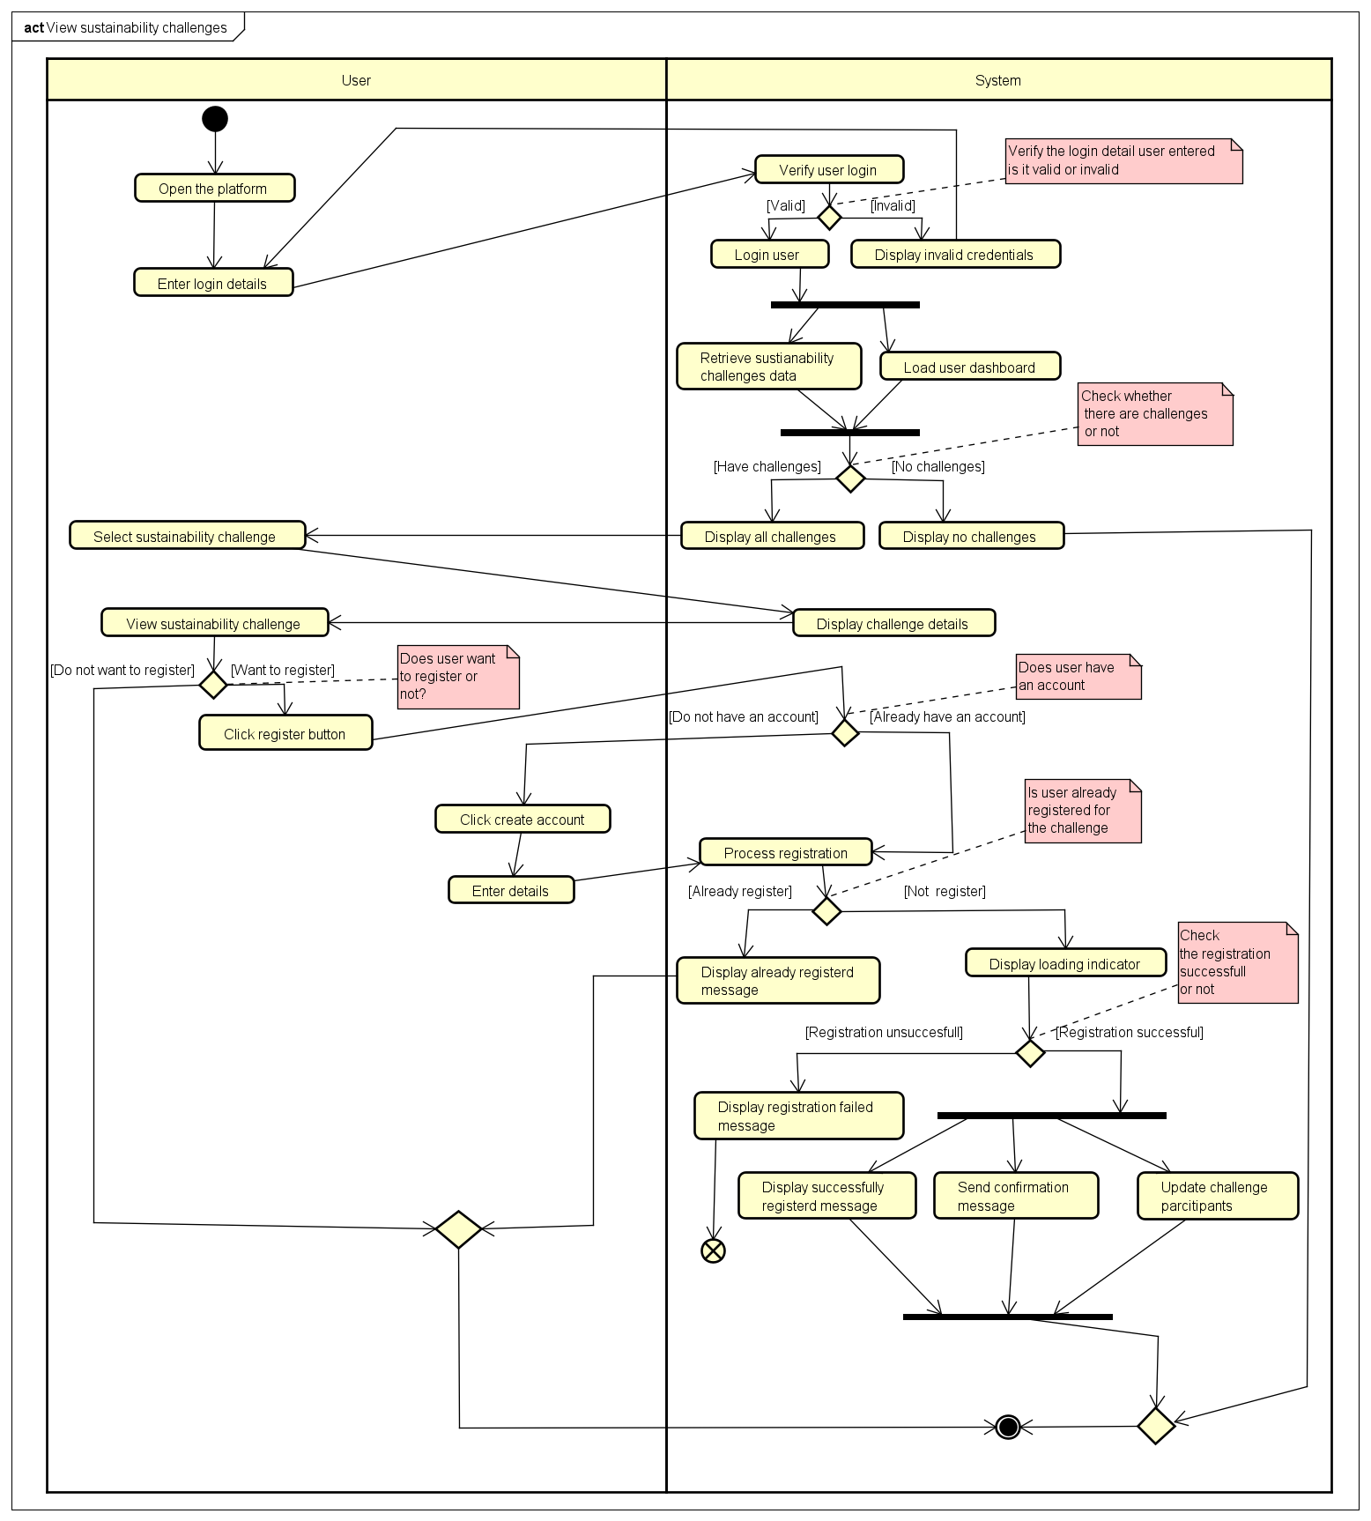
Vinudi Ranadeera – 20232111- W2120868 ( Feedback was given by Thisandi Hettiarachchi – 20231599 – W2120880 )
Figure 3:Activity Diagram for “View sustainability challenges” - Vinudi Ranadeera - 20232111- W2120868

6.2. Activity Diagram for “Upload sustainability challenges”
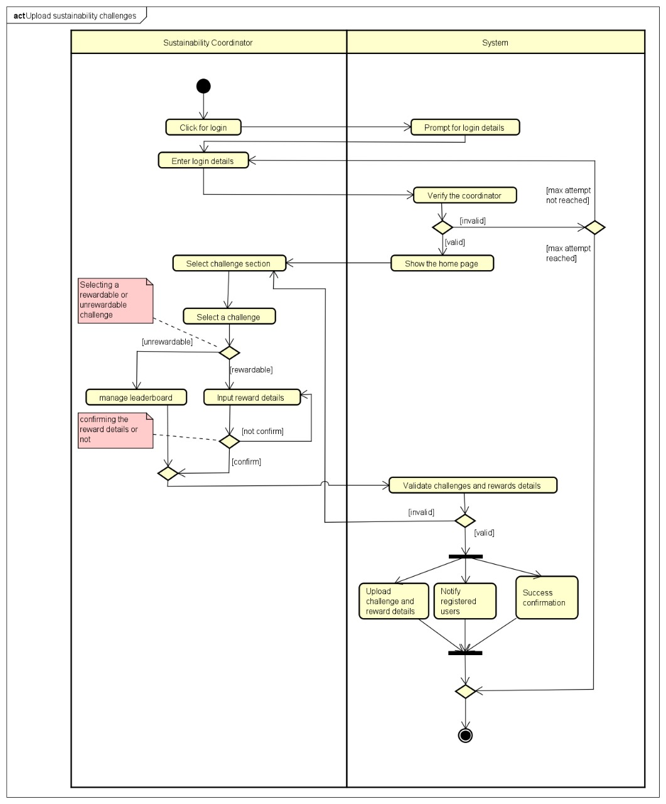
Thakshila Kavindi – 20232963- W2120881 ( Feedback was given by Akmal Azeez – 20230632 – W2120896
Figure 4: Activity Diagram for “Upload sustainability challenges” - Thakshila Kavindi - 20232963- W2120881

6.3. Activity Diagram for “View sustainability events”
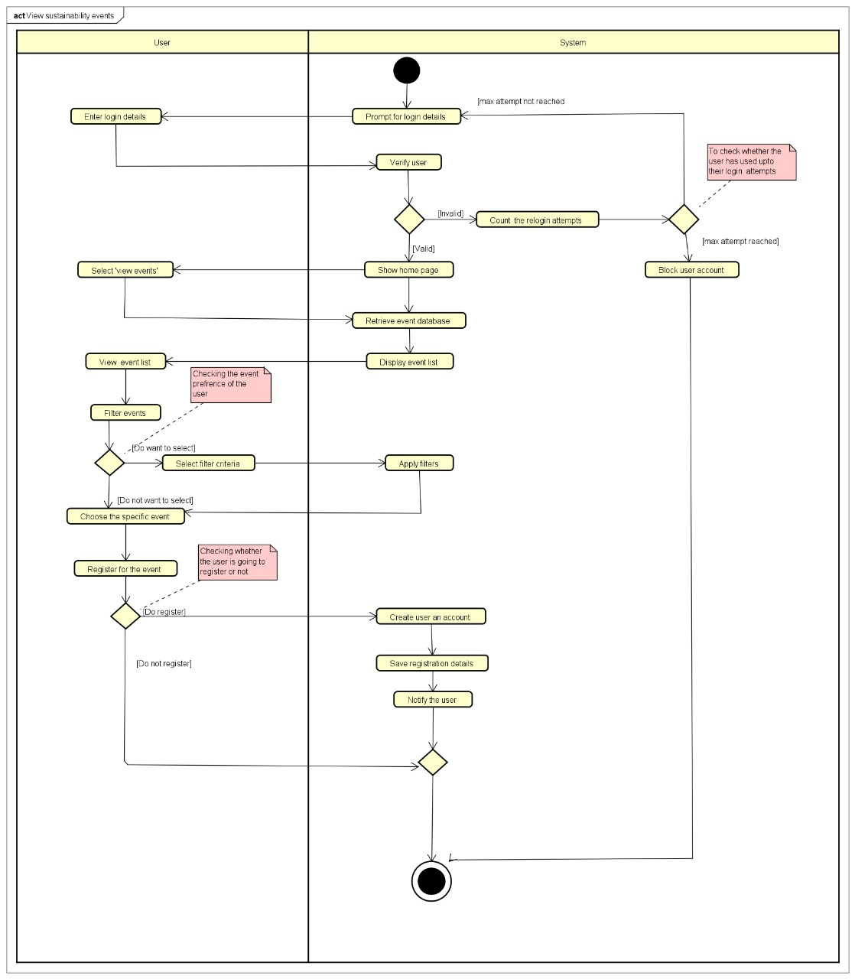
Thisandi Hettiarachchi– 20231599- W2120880 ( Feedback was given by Vinudi Ranadeera – 20232111 – W2120868 )
Figure 5:Activity Diagram for “View sustainability events” - Thisandi Hettiarachchi - 20231599 - W2120880

6.4. Activity Diagram for “View sustainability resources”
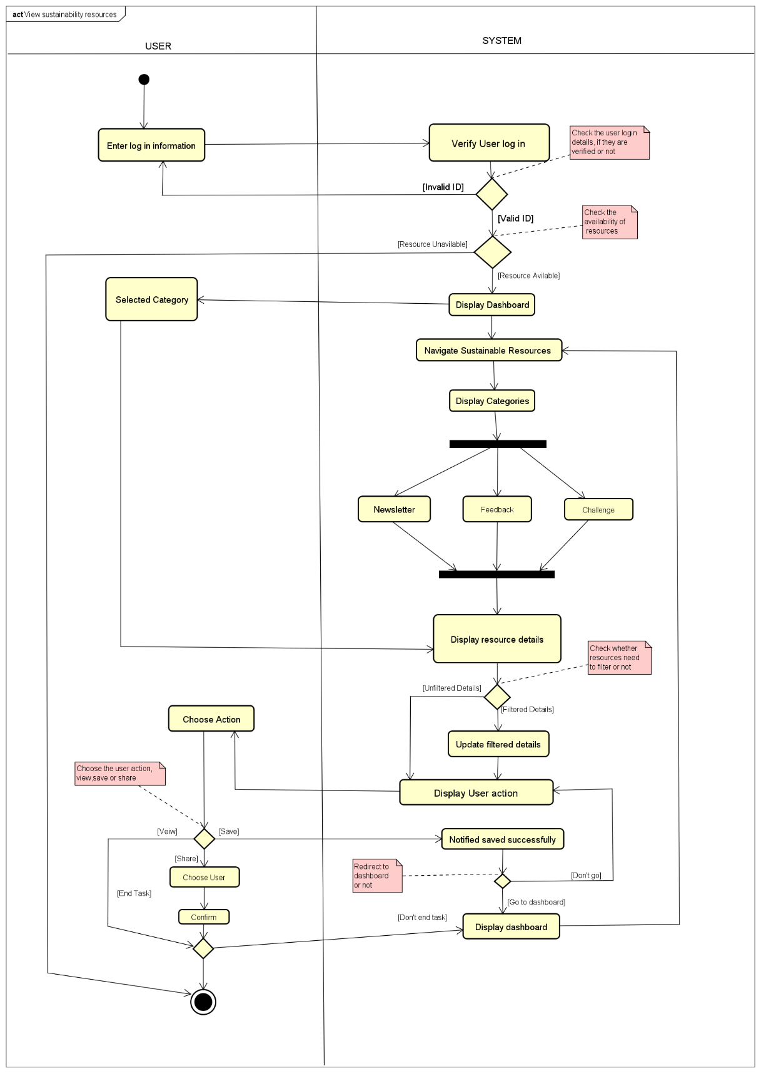
Muhammed Akmal – 20230632 – W2120896 ( Feedback was given by Thakshila Kavindi - 20232963- W2120881
Figure 6:. Activity Diagram for “View sustainability resources” - Muhammed Akmal - 20230632 - W2120896

References
Hamari, J., Koivisto, J. and Sarsa, H. (2014) ‘Does gamification work? – A literature review of empirical studies on gamification’, Proceedings of the 47th Hawaii International Conference on System Sciences (HICSS), pp. 3025–3034.
UNESCO (2021) Education for sustainable development: A roadmap, United Nations Educational, Scientific and Cultural Organization. Available at: https://unesdoc.unesco.org/ (Accessed: 10 March 2025).
University of Westminster (2023) Sustainability at Westminster, University of Westminster. Available at: https://www.westminster.ac.uk (Accessed: 10 March 2025).

APPENDIX

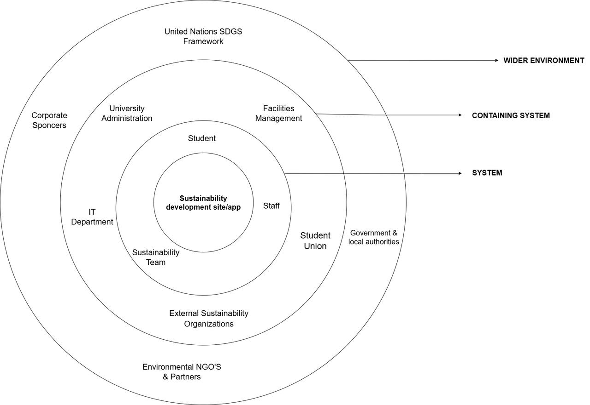
Appendix A – Draft / Earlier versions of Stakeholder Analysis
Figure 7:Draft / Earlier version of Stakeholder Analysis

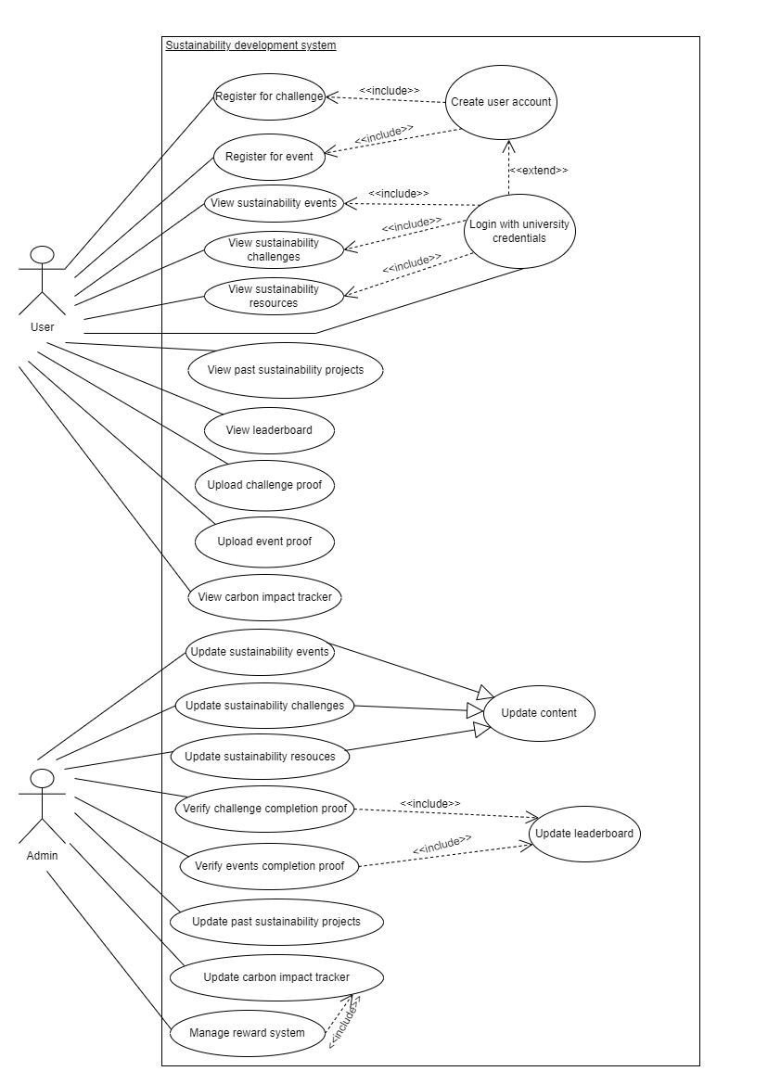
Appendix B – Draft / Earlier versions of Use case diagrams
Figure 8:Draft / Earlier versions of Use case diagram 1

Feedbacks given for earlier version of use case diagram from Miss.Aniqah Zeezan -
1. Replace actor admin with "Sustainability coordinator "
2. Register for challenge and register for event are depend on "View sustainability events and View sustainability challenges" (because sometimes, after viewing, the user may need to register)
3. Don't keep use case as 'Login with university credentials ' keep it as "Login user"
4. 'View sustainability events and User login' (Base use case - View sustainability events) include relationship. But the arrow heads are wrong.
5. Instead of saying upload events proof and upload challenge proof, use " Upload proof of completion "
6. Same for the verify challenge proof and events proof as well.
7. Update leaderboard is the main , verify proof of completion is the depend one.
8. 'Update carbon impact tracker' and 'Manage reward system'. Don't have any dependency.
9. After uploading proof user may gain rewards sometimes, because some challenges have rewards some are not.
10. Careful with the arrow heads

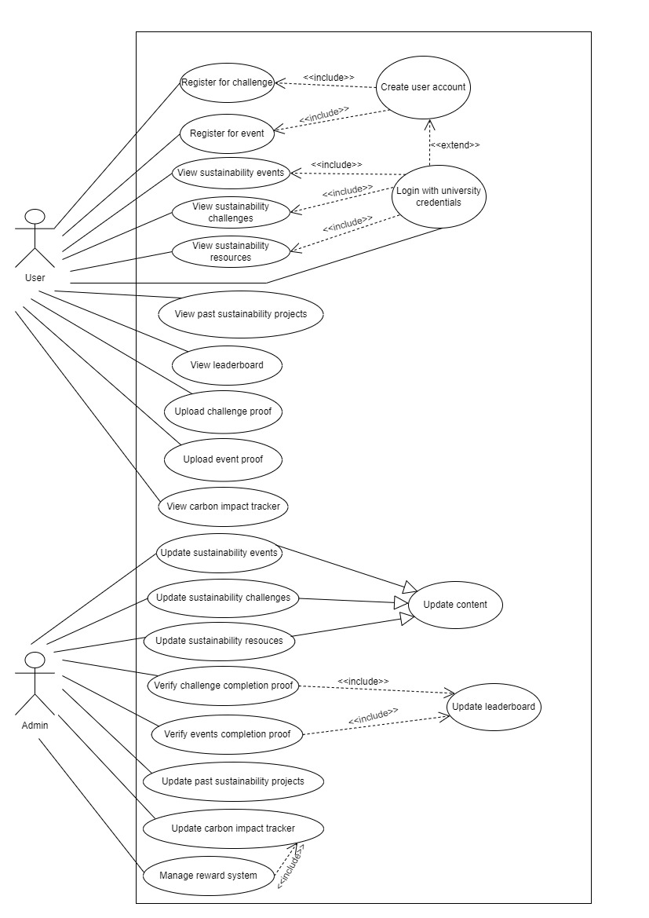
Figure 9:Draft / Earlier versions of Use case diagram 2

Appendix C – Draft / Earlier versions of Requirements
Requirement ID | Requirement | Requirement type | Use case
 | - User shall be able to register for sustainability challenges through the platform.  - The system shall allow users to sign up for sustainability challenges via an interactive interface.  - The system shall process challenge registrations within 3 seconds. | Functional requirement  Non-functional requirement | Register for sustainability challenges
 | - User shall be able to register for sustainability events through the platform. |  | Register for sustainability events
 | - User shall be able to upload proof of completion of challenges. |  | Showcase proof of challenge completion
 | - User shall be able to showcase proof of completion of events. |  | Showcase proof of event completion
 | - Admin shall manage the reward system. |  | Manage reward system
 | - User shall be able to view all sustainability challenges. |  | View sustainability challenges
 | - User shall be able to view all sustainability events |  | View sustainability events
 | - User shall be able to view all sustainability resources. |  | View sustainability resources
 | - Admin shall update sustainability challenges. |  | Update content
 | - Admin shall update leaderboard.  - The system shall automatically update scores when users complete sustainability challenges or events.  - The system shall support at least 1000 users being displayed on the leaderboard. | Functional requirement  Non-functional requirement | Update leaderboard
 | - Admin shall update event details. |  | Update Event Details
 | - Admin shall upload sustainability resources. |  | Upload sustainability resources
 | - Admin shall update past sustainability project records. |  | Update past sustainability project records
 | - User shall log in with their university credentials (ID & password). |  | Log In with University Credentials
 | - User shall be able to view past sustainability projects.  - The system shall store project details including images, descriptions, and results.  - The system shall use secure data storage to prevent unauthorized access to past project records. | Functional requirement  Non-functional requirement | View Past Sustainability Projects
 | - The admin shall update the carbon impact tracker  - The system shall calculate total carbon savings based on user activities.  - The system shall ensure accuracy by preventing duplicate or incorrect data entries. | Functional requirement  Non-functional requirement | Update Carbon Impact Tracker
 | - User shall be able to view carbon savings from various initiatives. |  | View Carbon Savings
 | - User shall be able to track their carbon footprints. |  | Track their carbon footprints.
 | - Admin shall verify challenge completion proofs. |  | Verify challenge completion proofs.
 | - Admin shall verify event completion proofs. |  | Verify event completion proofs
 | - Admin shall update user carbon footprint data. |  | Update user carbon footprint data
Table 4:Draft / Earlier version of Requirements

Appendix D – Draft / Earlier versions of Activity Diagrams (group by student) & feedback

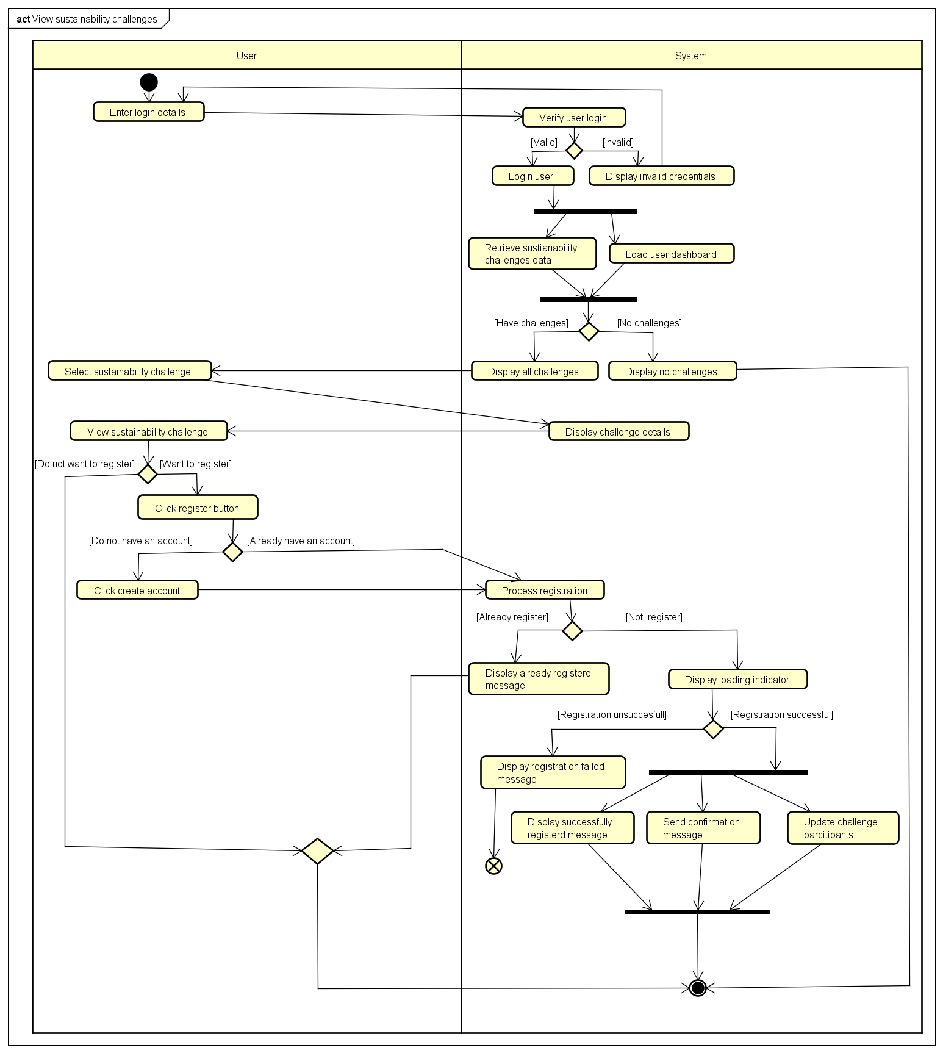
Vinudi Ranadeera-20232111- W2120868 Earlier version of Activity Diagram for “View sustainability challenges”
Figure 10:Vinudi Ranadeera-20232111- W2120868 Earlier version of Activity Diagram for “View sustainability challenges”

Feedbacks were given by Thisandi-20231599-W2120880
- Add notes for decision boxes
- Add a merge node
- The "Check if user has an account" process should be in the System swim lane, since the system verifies this.
Changes made
- Added the notes
- Added the merge node
- Adjust the swim lane

Thakshila Kavindi-20232963- W2120881 Earlier version of Activity Diagram for “Upload sustainability challenges”
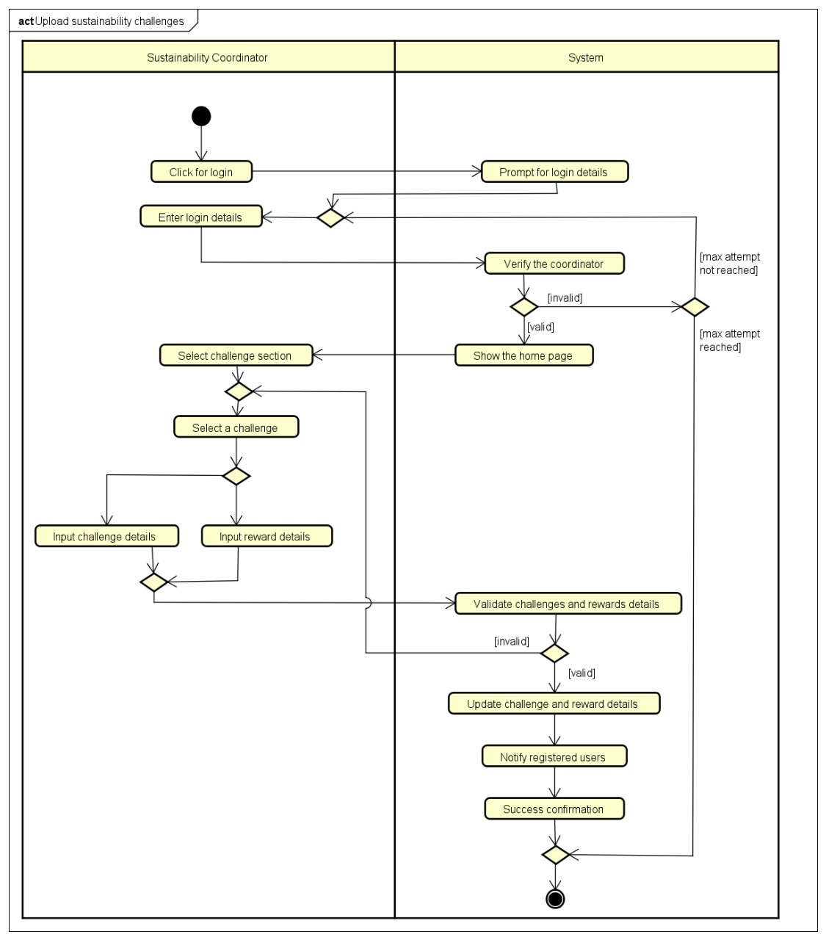
Figure 11:Thakshila Kavindi-20232963- W2120881 Earlier version of Activity Diagram for “Upload sustainability challenges”

Feedbacks were given by Akmal Azeez-20230632-W2120632
- The "Select challenge section" needs more specific options like "unrewardable" and "rewardable" for clarity.
- The validation process should be more distinct to ensure proper checks before updates.
- Adding a "Success confirmation" step would provide a clear endpoint.
- Positioning "Notify registered users" after success confirmation would improve the flow.
Changes made
- The updated diagram adds specific options like 'unrewardable,' 'rewardable,' and 'manage leaderboard' for clearer challenge selection.
- It introduces defined steps for validating challenges and rewards, which were unclear in the original.
- A 'Success confirmation' step has been included to mark the process endpoint, which was missing earlier.
- The 'Notify registered users' step is now placed after success confirmation, improving the process flow.

Thisandi Hettiarachchi-20231599- W2120880 Earlier version of Activity Diagram for “View sustainability events”
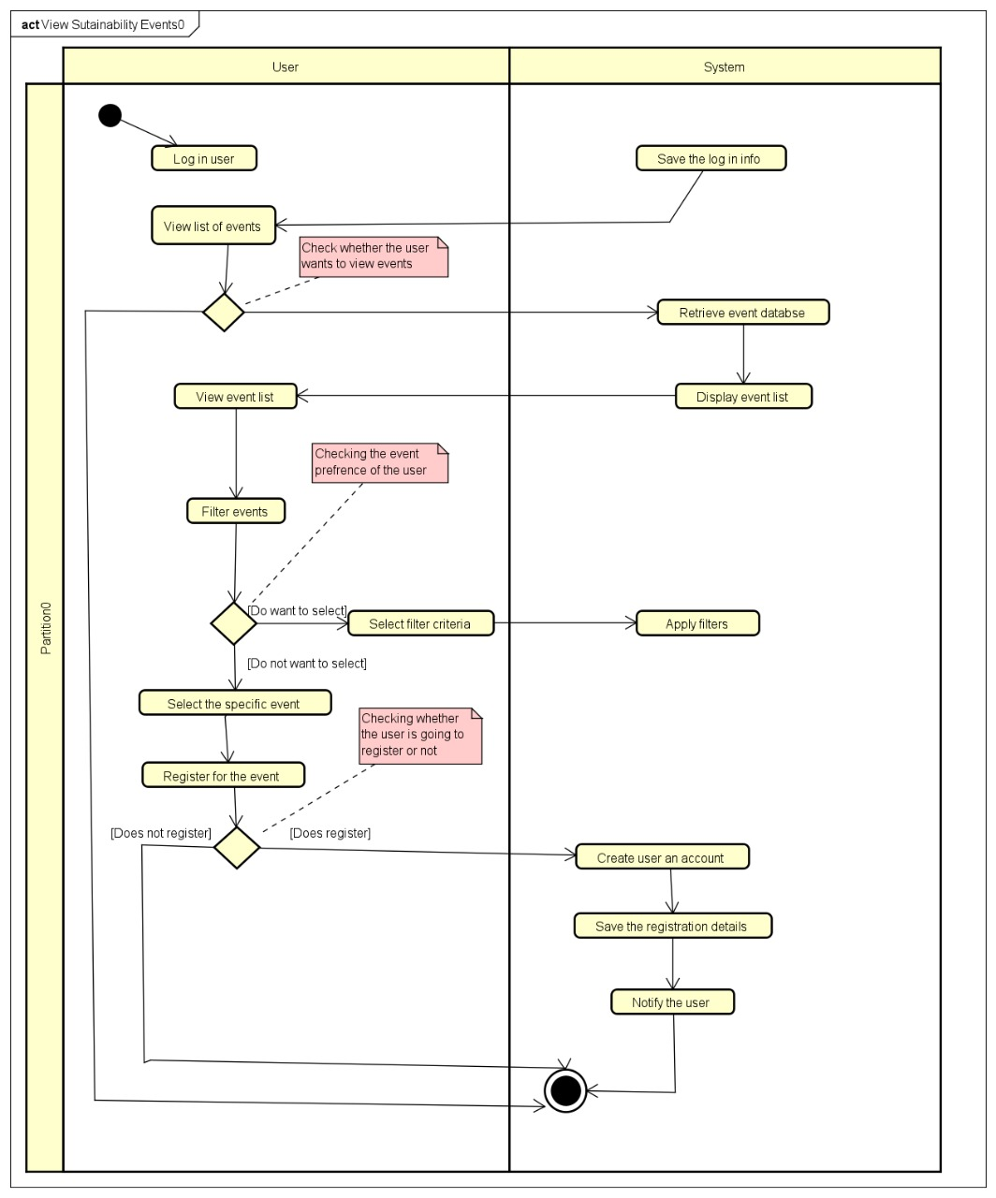
Figure 12: Thisandi Hettiarachchi-20231599- W2120880 Earlier version of Activity Diagram for “View sustainability events”
Feedbacks were given by Vinudi Ranadeera-20232111-W2120868
- Clearly labeling the decision nodes.
- Add more action nodes to clear the flow.
- Add more guard conditions.
- Clear out the control flows more to get a clear view.
Changes made
- Added clear labeling to the decision nodes.
- Added more action nodes to clear the flow.
- Added more guard conditions.
- Cleared out the control flows more to get a clear view.

Muhammed Akmal-20230632- W2120896 Earlier version of Activity Diagram for “View sustainability resources”
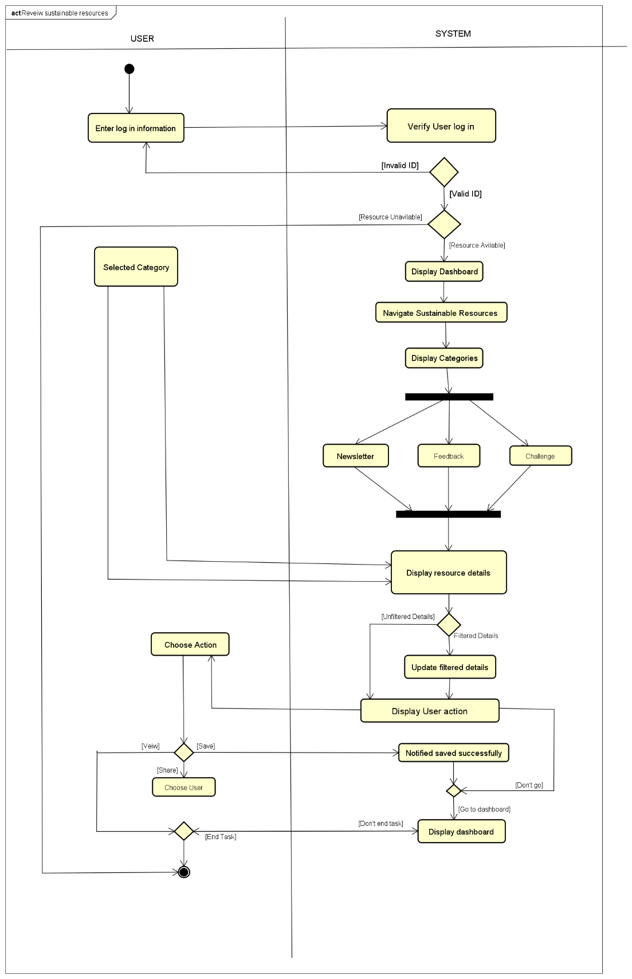
Figure 13:Muhammed Akmal-20230632- W2120896 Earlier version of Activity Diagram for “View sustainability resources”
Feedbacks were given by Thakshila Kavindi-20232963- W2120881
- Use case name is not correct
- Recheck the control flows
- Check the directions of the decision boxes
- For the decision nodes, apply notes
Changes made
- Corrected the use case name
- Checked the control flows
- Corrected the decision boxes
- Applied notes

Appendix E – Interview script
Interviewer: Akmal, Vinudi
Interviewee: Miss Aniqah and Miss Janandi
Date: 13th February 2025
Time: 11.45a.m – 12.00p.m
Location: Lab 1 Dialog Building
Current awareness & engagement challenges
- "How aware are students about sustainability efforts on the campus?"
Answer – they are aware of to some extent, some students who are regularly taking part of these events they are aware of it. But there are good amount of students who are keen to do it, but they still don’t know how to take part in these kinds of events. So we won’t say we are 100% awareness in the current system because the current system is only giving information about the events, even the events we had in the past, even events challenges in the past are having in the present, so its only giving information the present system. So we want the proposed system, the new one to engage more with the students and staff who are willing to take part in these challenge. Like they shall be able to register through this platform, for a challenge or an event, show case their proof of completeness everything okay? So they want them to be more engage with the platform not only give them the information.
- “So the engagement with the platform are there minority or 50-50?”
Answer – Maybe pretty less only, because some knows about it and they are aware of it, some like to participate but they don’t know how to do take part of those, currently we have low that’s why we want the platform to get more engage with them.
- “What are the biggest challenges in engaging them(low rate)?"
Answer – We are not getting lots of participants for these events and the challenges we have conduct them. Current platform only give them the information, they don’t know where to register for those events and challenges. Current platform they can’t register through the platform.(Awareness)
Content & Motivation
- “What type of content do you think will capture students' attention?”
Answer – Content you don’t have to worry about it, content will be added by the admin, who is from the sustainability team coordinator.
New system they can be add leaderboard, which is giving badges, awards, awards like once we completed the activity users will be able to upload or give a evidence of what they did and after giving that evidence only we can give them a reward, so not the all the activities will have a reward some activity if there is a reward and if they have complete they will be getting it, otherwise they will be recognized through the leaderboard, so the leaderboard will be created by the admin and the user can be applicable for those able to view the leaderboard(to Motivate)
- “Have rewards worked in past sustainability initiatives?”
Answer – Yes, they are many and they were challenges conducted by Westminster. So that is also they are in that website.
Functional & Technical Requirements (5 mins)
User interactions & features
- "Who are the primary users and what should they be able to do?
Answer – Westminster students and Westminster staff are the primary users, it will be only for the students and staff of Westminster, as a user who can view all these events and challenges and take a part of it, that will be them, but then all these events challenges and other resources will be updated by the admin. So who will be from the sustainability team coordinator.
- “Should it be a website, mobile app, or part of the university portal?”
Answer – We want a website, but it has to be mobile compatibility website.
Performance & Access
- "What are your expectations for platform speed and performance?"
Answer – You can suggest the best, but we want it to be fast and convenient.
- “Should it work offline or require an internet connection?”
Answer – Only online, no need to be offline.
- “What level of security/authentication should be in place?”
Answer – The system is only accessible for university staff and students, they can even view the content through you have to log in through your university ID and password, then only you can even view the content, but however if you want to take part in any event or challenge then you have to create an account in this platform.
- “Should access be restricted to university members only? What about the alumni?”(10 mins)
Answer – At the moment only for students and staff who are in the university. As long as email is active you can access.
- “Would you have any further improvements for us?”
Answer – Yes, one more important thing we want to highlight is the coordinator (the admin) Shall be able to update that carbon impact catalogue or the tracker. We are having lots of events and challenges not only that how this carbon impact we have created, so it will be updated by the sustainability coordinator. User can view the carbon savings. Basically, they shall be able to view all events and challenges and take part in anything in they are interested and although they shall be able to view the past projects and all and see what saying and they shall be able to see their leaderboard and achievements.

